Overview

This lab will provide an overview of how to perform queries, inserts, updates and deletes using REST and PHP Data Objects (PDO). We will be doing the following things:

- Configuring our PHP file
- Retrieving data from a RESTful interface
- Changing the database using a RESTful interface

Exercise 1: Configuring our PHP File

Upload the file editstaff.php to your public_html directory and edit it. Right at the very beginning of the file is the line “//Put db link here.” Change that line to say $mydb=new PDO… as per the previous lab.

Once you do that, the file should be able to execute, and you should see a screen that looks like this:

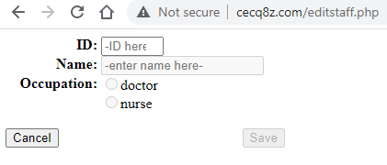

You should observe the web page runs with errors. For example, if you key in an ID, it will tell you getstaff.php is not found.

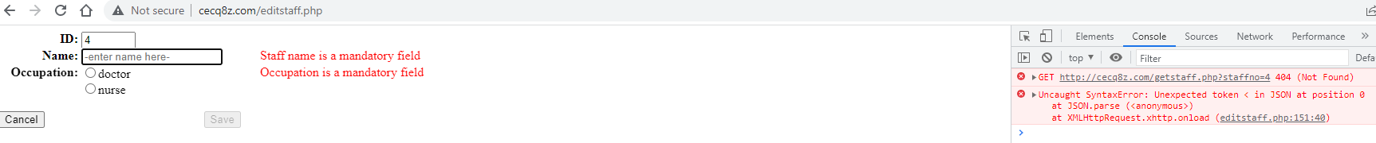

This lab will be about creating these additional files. For now, let’s observe what editstaff.php does. If you specify that the staff is a nurse, it will ask you to key in a ward number.

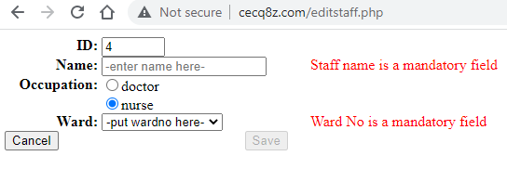
If you specify this is a doctor, it will ask you for the doctor’s specialty and position.
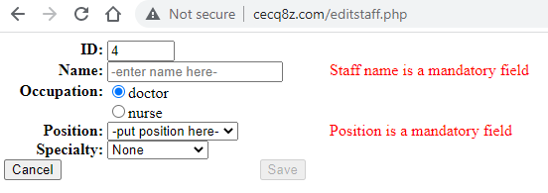
If you key in all the required fields, the save button will be enabled.
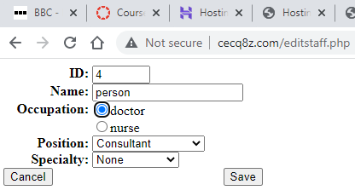

However, pressing the save button will generate another 404 error.
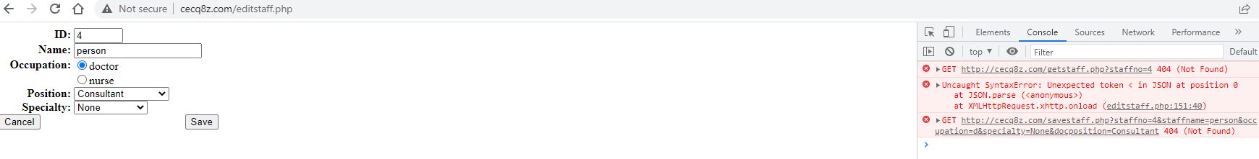
We need to develop two modules, getstaff.php and savestaff.php. Getstaff.php will retrieve information about staff using the staff number while savestaff.php will save information to the database.

The idea of a webpage calling another webpage to do information querying and manipulation is called REST, which stands for Representation State Transfer. The idea behind REST is that particular pieces of code perform services for other pieces of code. The code performing the service is dedicated to performing that particular service and we can write the code free of the need to worry about other things like how to make our website look good.

Exercise 2: Retrieving Data From a RESTFul Interface

Getstaff.php is going to need to communicate data to editstaff.php. To do this, it will need a standard way of doing so. The most popular data exchange standard on the web today is called Javascript Object Notation. JSON data fundamentally looks like a number of attribute/value pairs. For example, what we want getstaff.php to output for staffno 192 is

{"staffno":"192","0":"192","staffname":"Wilkie","1":"Wilkie","occupation":"n","2":"n","wardno":"w2","3":"w2","docposition":null,"4":null,"specialty":null,"5":null}

Notice how everything in this structure is of the form “attribute name” : “attribute value.”

We have staffno is 192, attribute 0 (staffno) is 192, staffname is Wilkie, attribute 1(staffname) is Wilkie, etc.

JSON is generally more popular than XML, which is another data exchange standard, because JSON is a lot less wordy.

Editstaff.php communicates with Getstaff.php using standard http. If you read the editstaff.php code, you will see this line:

xhttp.open("GET", "getstaff.php?staffno="+staffno.value, true);

Basically, editstaff is issuing a HTTP get command to getstaff.php and passing it a variable called staffno.

Getstaff.php is going to take in staffno as input and generate the JSON as output. To do this, it is going to have to run an SQL query. If you recall our normalization lesson, staff is subclassed into doctor and nurse. We now need data from all three tables to be sent to editstaff.php. We are thus going to have to denormalize our database with an SQL query.

The specific SQL query we will use is:

Select staff.staffno, staffname, 'n' as occupation,
wardno, null as docposition, null as specialty ".
from staff inner join nurse on staff.staffno=nurse.staffno
where staff.staffno=<staffno from input>
union
Select staff.staffno, staffname, 'd' as occupation,
null as wardno, docposition, specialty
from staff inner join doctor on staff.staffno=doctor.staffno
where staff.staffno=<staffno from input>

Based on our existing hospital database, this query can result in two possibilities- a record is found, or a record is not found. If the record is found, the occupation will be ‘n’ if a nurse, or ‘d’ if a doctor. If the record is not found, we will report an error.

The relevant code for getstaff.php is as below. I expect you to fill in the appropriate blanks.

<?php

$staffno=$_REQUEST['staffno'];

//Code to establish connection to PDO goes here. Call it $mydb

$stmt=$mydb->prepare("<SQL code goes here. Don’t forget to mark the appropriate variable :staffno>"

);

$stmt->execute([":staffno"=>$staffno]);

$result=$stmt->fetch();

if ($result==false)

echo 'ID not found!';

else

{

echo json_encode($result);

}

If you did everything correctly, at this point, you should be able to retrieve data using editstaff.php

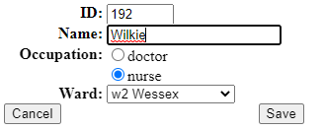

Exercise 3: 3. Changing the database using a RESTful interface

Changing the database is going to be done in a similar way. We will pass a set of variables to savestaff.php. If you look at the code of editstaff.php, you will see the following lines:

if (isdoctor.checked)
xhttp.open("GET", "savestaff.php?"+
"staffno="+staffno.value+
"&staffname="+staffname.value+
"&occupation=d"+
"&specialty="+specialty.value+
"&docposition="+position.value, true);
else
xhttp.open("GET", "savestaff.php?"+
"staffno="+staffno.value+
"&staffname="+staffname.value+
"&occupation=n"+
"&wardno="+wardno.value, true);

Basically, if this is a doctor, send the staffno, staffname, docposition and specialty. Otherwise (this is a nurse) send the staffno, staffname, and wardno.

The logic for savestaff.php is going to be as follows. First, we will query the database to see if the staffno exists in staff. If it does, we will update the staff record. Otherwise, we will insert a new staff record in.

We will then delete the corresponding doctor and nurse entries for that staff member and insert a new record into either the doctor or nurse table. We do this, because this is simpler code to write than figuring out whether the doctor or nurse exists, and then either inserting or updating the respective tables. Also, this allows me to show you how to do a delete in PDO (which is exactly the same as doing a select, insert, or update.

Mathematically, a change in state is equivalent to deleting the thing that changed state and adding it back in with the new state. This is actually a very common practice in much of computing and occurs in all kinds of places including the saving of files. If you ever wonder why your Word file can get destroyed during a save, this is the reason. Word deletes your file and then recreates it on disk.

We will need to perform a whole bunch of queries. First, we will need to check if the record exists.

Select staffno
from staff
where staffno=<staffno from input>

We will then need to either insert or update the staff table.

insert into staff (staffno, staffname) ".
"values(<from input>,<from input>)

And

update staff
set staffname=<from input>
where staffno=<from input>

Next, we will delete records from doctor and nurse

delete from <doctor/nurse>
where staffno=<from input>

and then we will have to insert the appropriate records into doctor or nurse.

The relevant code for savestaff.php is as follows. I trust you to fill out the blanks.

<?php
$staffno=$_REQUEST['staffno'];
$staffname=$_REQUEST['staffname'];
$occupation=$_REQUEST['occupation'];
$wardno=$_REQUEST['wardno'];
$specialty=$_REQUEST['specialty'];
$docposition=$_REQUEST['docposition'];
$jsonfile = file_get_contents('dbinfo.json');
$dbinfo = json_decode($jsonfile, false);
$isupdate=false;
//establish the connection here. The variable must be $mydb
$stmt=$mydb->prepare(<the select query>
);
$stmt->execute([":staffno"=>$staffno]);
$result=$stmt->fetch();
if ($result==false)
{
$isupdate=false;
$stmt=$mydb->prepare(<insert into staff>)"
);
$stmt->execute([":staffno"=>$staffno, ":staffname"=>$staffname]);
}
else
{
$isupdate=true;
$stmt=$mydb->prepare(<update staff>
);
$stmt->execute([":staffno"=>$staffno, ":staffname"=>$staffname]);
}
$stmt=$mydb->prepare(<delete doctor>
);
$stmt->execute([":staffno"=>$staffno]);
$stmt=$mydb->prepare(<delete nurse>
);
$stmt->execute([":staffno"=>$staffno]);
if ($occupation=='n')
{
$stmt=$mydb->prepare(<insert into nurse>
);
$stmt->execute([":staffno"=>$staffno, ":wardno"=>$wardno]);
}
else
{
if ($specialty=='None')
{
$stmt=$mydb->prepare(<insert into doctor- only the fields staffno and docposition>)"
);
$stmt->execute([":staffno"=>$staffno, ":docposition"=>$docposition]);
}
else
{
$stmt=$mydb->prepare(<insert into doctor- the fields staffno, specialty and docposition>)"
);
$stmt->execute([":staffno"=>$staffno, ":specialty"=>$specialty, ":docposition"=>$docposition]);

}
}
if ($isupdate)
echo 'Updated staff number '.$staffno;
else
echo 'Inserted new staff number '.$staffno;
?>

If you did everything correctly, the system will now save records.

