Overview

This lab will provide an overview of how to connect to a database using PHP Data Objects (PDO). We will be doing the following things:

- Mounting our PHP file
- Connecting to the database
- Setting up a simple select query
- Displaying the query result

Exercise 1: Mounting our PHP File

You should have available to you a file called listpatients.php. Upload this file to your web account. If you are using 000webhost, you use File Manager, and click on this icon  to upload a file.

Make sure it is in the directory public_html.

Check you can see the file in your browser. To do this, go to http://<your website>/listpatients.php

If you are successful, this is what you should see:

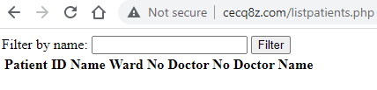

Exercise 2: Connecting to the Database

The command to connect to the database in PHP PDO, is new PDO. You will need the database name, username and password. You can find the database and username in MySQL

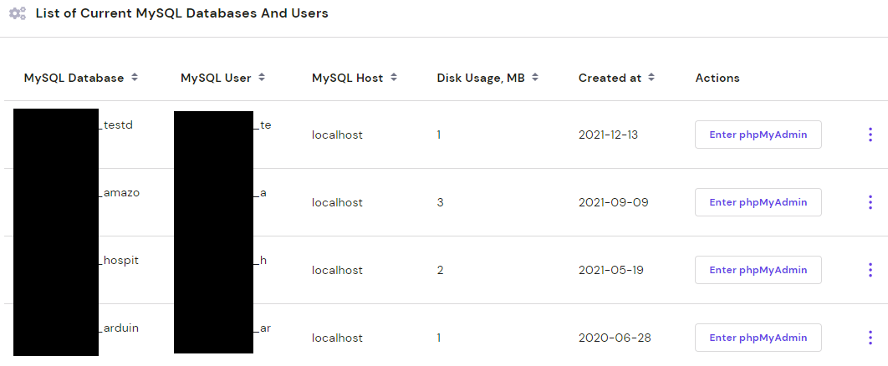

You will have to remember the password. If you have forgotten, use the to change the password.

Edit the listpatients.php file with the  icon. Inside, you will see a line
//Code for Exercise 2 goes here.

Replace that line with

$mydb = new PDO('mysql:host=localhost;dbname=<database name>', ‘<database user>’,’<database password>’);

The things in the <> including the <> should be replaced by the respective database name, user and password.

Save the file and refresh the page on the browser. If it shows the exact same thing as before, you have successfully connected to the database. Otherwise, you have some kind of error.

Exercise 3: Setting Up The Query
As you can see from the form, we want to retrieve the list of patients in our hospital. If the filter is blank, we want to retrieve all our patient information. Otherwise, we only want to retrieve patients that have a wildcard matching name.

In the PHP, you will notice there is already this piece of code:
$namematch=$_REQUEST['filtername'];
if (strlen($namematch)==0)
$filtermatch='%';
else
$filtermatch='%'.strtoupper($namematch).'%';

What this code does is put % signs beside anything coming from the web form filter. If there is nothing coming from the filter, it just puts a single % sign. It does this because % is the wildcard character for the SQL Like operator. We will be using the Like operator in our query.

Fundamentally, we are going to run the query

Select patientid, name, wardno, doctorno, staffname
from patient inner join staff
on doctorno=staffno
where upper(name) like [what is in filtermatch]

Replace the line //Code for Exercise 3 goes here

With

$stmt=$mydb->prepare("Select patientid, name, wardno, doctorno, staffname ".
"from patient inner join staff ".
"on doctorno=staffno ".
"where upper(name) like :filtermatch");
$stmt->execute([':filtermatch'=>$filtermatch]);

The period (.) is the PHP concatenation character. Be careful and note the spaces before the quotation marks (space” .). This is important because spaces separate words in SQL. If you don’t put those spaces in, your RDBMS will report an error.

In PDO, colon variablename (:filtermatch) is used to mark where a variable goes in the query. We first prepare the SQL statement. We then execute the statement, swapping the marker with the PHP variable using [':<marker>'=>$<variable>]]

Save your file and reload your PHP code. Once again, if there was no change, everything was fine. If the page crashed, you have an error.

Exercise 4: Displaying The Query Result

The query result was stored in the $stmt variable. We now have to embed the query result in the PHP file.

Replace the line <!--Code for Exercise 4 goes here--> with

<?php
foreach ($stmt as $row)
{
?>
<tr>
<td><?php echo $row['patientid'];?></td>
<td><?php echo $row['name'];?></td>
<td><?php echo $row['wardno'];?></td>
<td><?php echo $row['doctorno'];?></td>
<td><?php echo $row['staffname'];?></td>
</tr>
<?php
}
?>

Save the file. If all goes well, when you refresh the page, you should see:

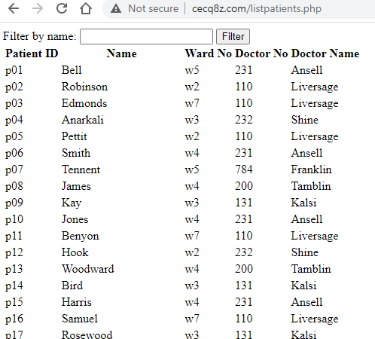

If you apply a filter, the result should change.

