Lab: Creating Tables and Relationships in MySQL

Objectives

This lab will cover the creation of tables and relationships in MySQL. In this lab, we will go over a number of features MySQL has to protect the integrity of your data, and to make data representation more attractive. Specifically, we will learn how to:

- Set keys and unique attributes
- Set default values
- Establish referential integrity
- Set validation rules
- Create indexes
- Perform cascade deletes

Outline

This lab is divided into four parts:
- Setting Up
- Creating the Degree and HasDegree Tables
- Creating Indexes
- Setting Up Relationships

Overview

The HW assumes you already have the hospital database installed in MySQL.
Our task is to create a table of degrees and then allocate those degrees to the doctors and nurses.

Creating the Degree Table

We’re going to create a table of possible degrees. A degree has a degree code (e.g., BNur) and a degree name (e.g., Bachelor of Nursing).

To do this, click on the New option in the list of tables.

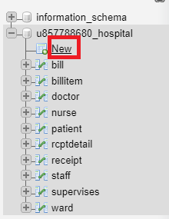

Call the table udegree.

Then, right click under “Column Name” and select “Create New Column.”

Create two attributes- degreecode which is varchar(5) and degreename which is varchar(100).

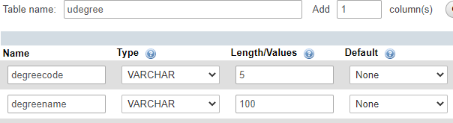

Save the table by pressing the button.

We want DegreeCode to be our primary key. Click on the checkbox next to degreecode and select .

Now, we need to create a table to assign degrees to staff. This table will have the staffno- char(3), the degreecode- varchar(5), the yearearned (int), and the institution the degree was earned from- varchar(100). Note that the primary key and foreign key must always have exactly the ame data type. Staffno, degreecode is the primary key for this table.

Create the table staffdegree.

We now want to link our new table to the existing tables staff, and degree. We want the staffno to link to the table staff.
Click on the . Name the new constraint FK_sdegree_staff.
Set on delete to cascade and on update to cascade. What this does is that if the staffno of the staff table changes, the staffno in the staffdegree table will also change. The columns to link are, of course, staffno.

Create another foreign key relationship between staffdegree and degree. Click on to do this. The relationship should also be on cascade for both the delete and update.

Then save the changes.

We’re going to create two degrees in the degree table. In SQL, execute the following queries:

INSERT INTO udegree(degreecode, degreename)
VALUES ('BNur','Bachelor of Nursing');
INSERT INTO udegree(degreecode, degreename)
VALUES ('MD','Masters of Medicine');

Now, try the following:

INSERT INTO staffdegree(staffno, degreecode, yearearned, institution)
VALUES ('110', 'BBA', 1995, 'Sam Houston University');

Notice how it doesn’t work. This is because a BBA has not been defined in UDegree. The following will work:

INSERT INTO staffdegree(staffno, degreecode, yearearned, institution)
VALUES ('110', 'MD', 1995, 'Sam Houston University');

Export a screenshot showing that this record has been successfully inserted into the database (select * from staffdegree) and submit that as proof you have completed the assignment.

